|  |  |  |  |
| --- | --- | --- | --- |
| **TITLE:** | AR-02 Cargowise New Customer Set up | | |
| **sop #:** | BIS-05 | **revision #:** | 1 |
| **EFFECTIVE DATE:** | May 20, 2020 | | |
| **OWNER:** | Jonathan Lutz | | |

## REVIEWERS

|  |  |  |  |
| --- | --- | --- | --- |
| Name | tITLE | sIGNATURE | dATE |
| Fraser Greig | Solution Design Manager | Signed | May 20, 2020 |

## APPROVER

|  |  |  |  |
| --- | --- | --- | --- |
| Name | tITLE | sIGNATURE | dATE |
| Jonathan Lutz | Director, Solutions Design and BI | Signed | May 20, 2020 |

# 1.0 purpose

New customer account set-up

# 2.0 SCOPE

Covers process to setup new customers

# 3.0 equipment

N/A

# 4.0 definitions

|  |  |
| --- | --- |
| **Definition** | **Explanation** |
|  |  |

# 5.0 Responsibility

|  |  |
| --- | --- |
| **Responsibility** | **Activity** |
|  |  |

# 6.0 policy

## 6.1 GENERAL

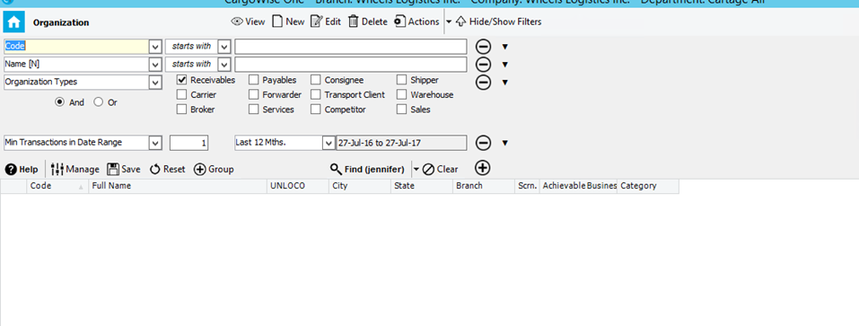

1. Controlling Branch: Always “YYZ” – Fill in all related information and check off “receivables”

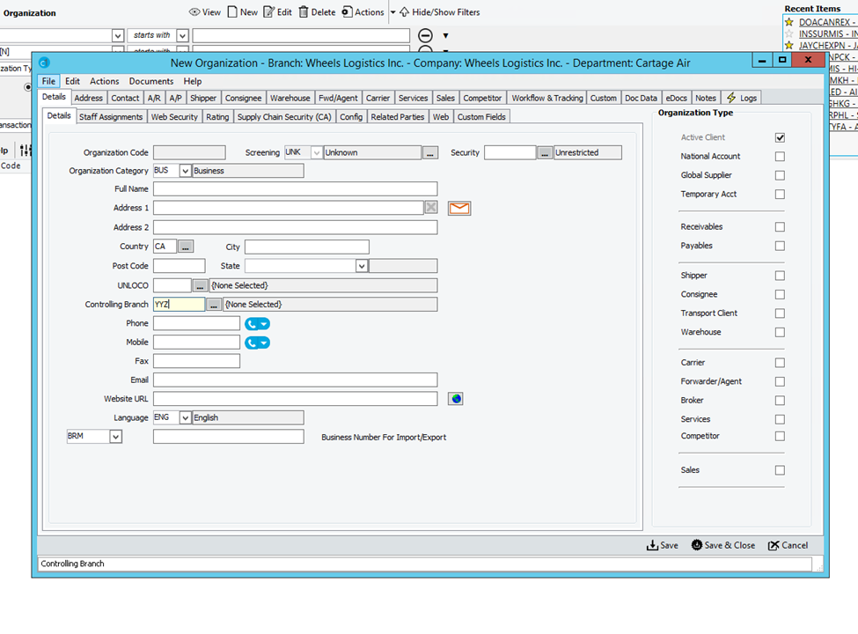

1. “Accept as Entered”

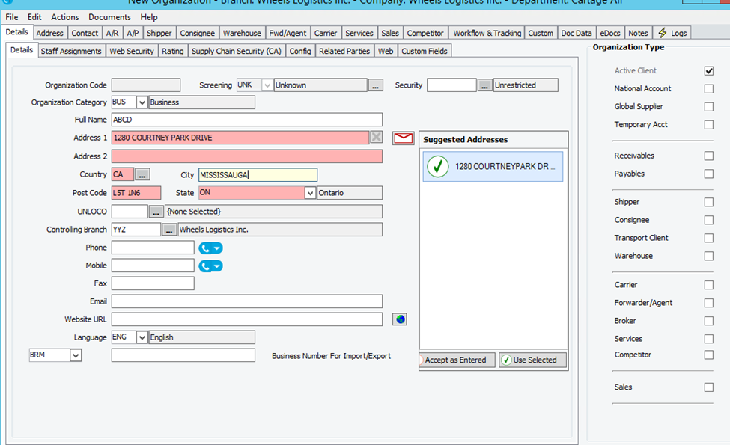

1. Now Click UNLOCO … and ender City under Port Name and Click Find

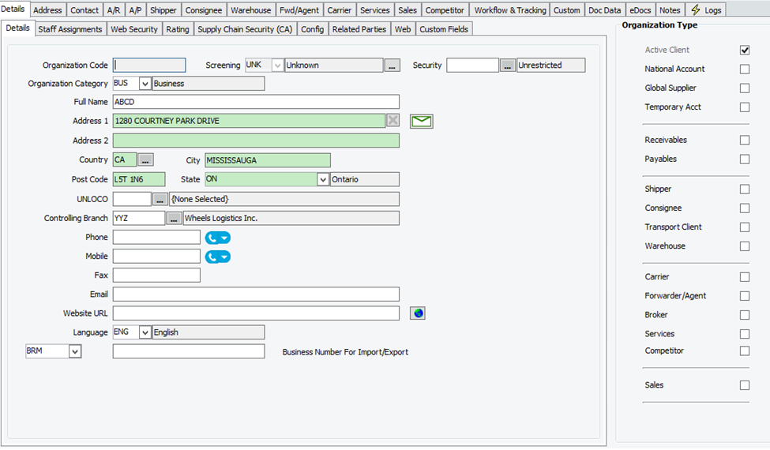

1. Go To Staff Assignments

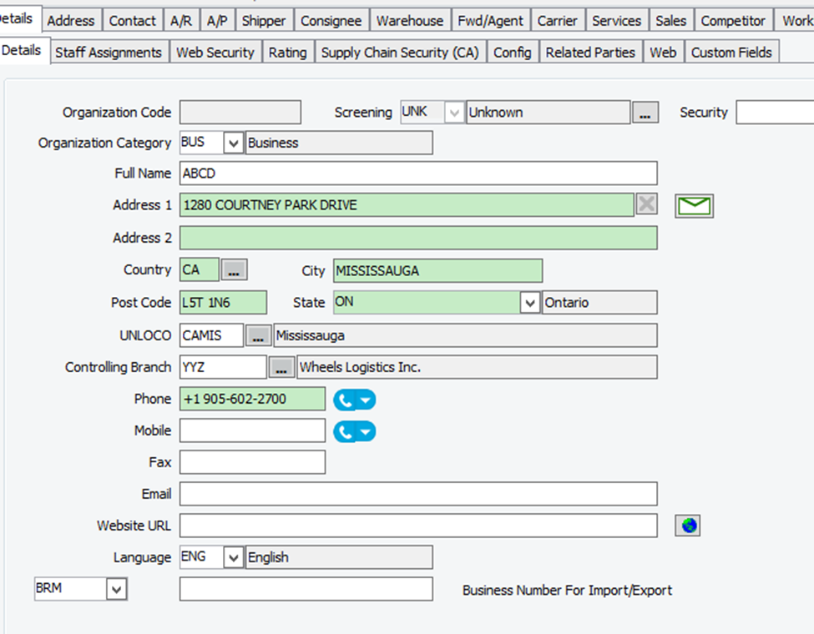

1. Enter SAL, under initial click the …

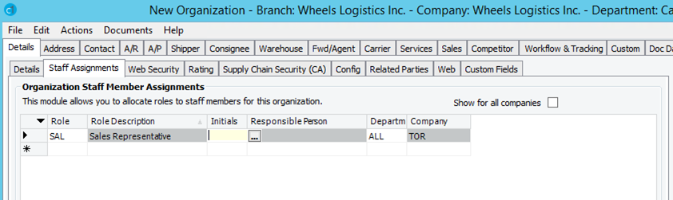

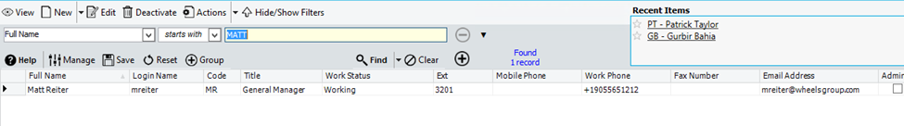

1. Double click – it will take you to the original screen

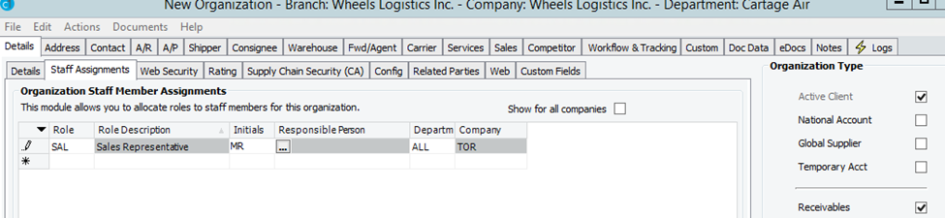

1. Click Contact: Enter information (All contacts)

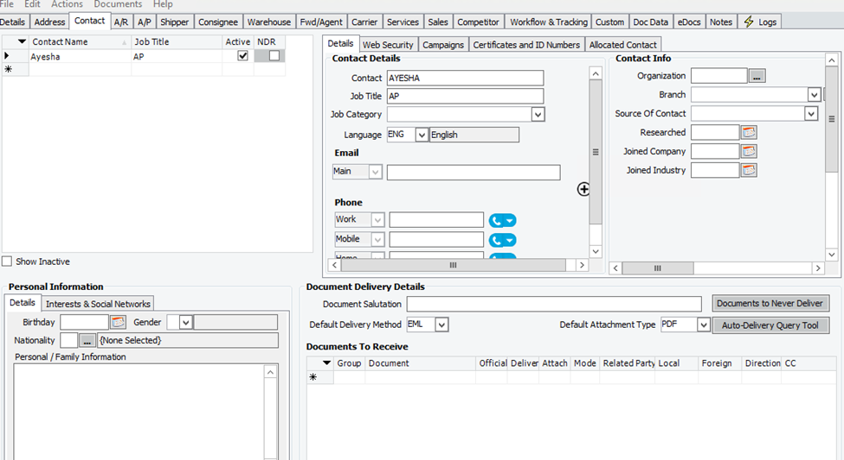

1. Enter Currency

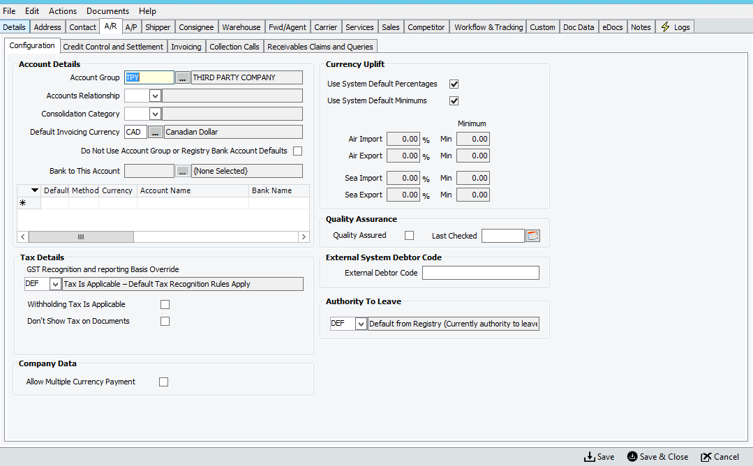

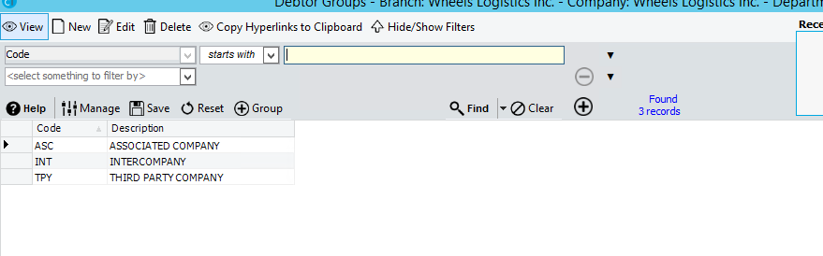

1. Click Credit Control and Settlement – Enter credit limit/COD information as required

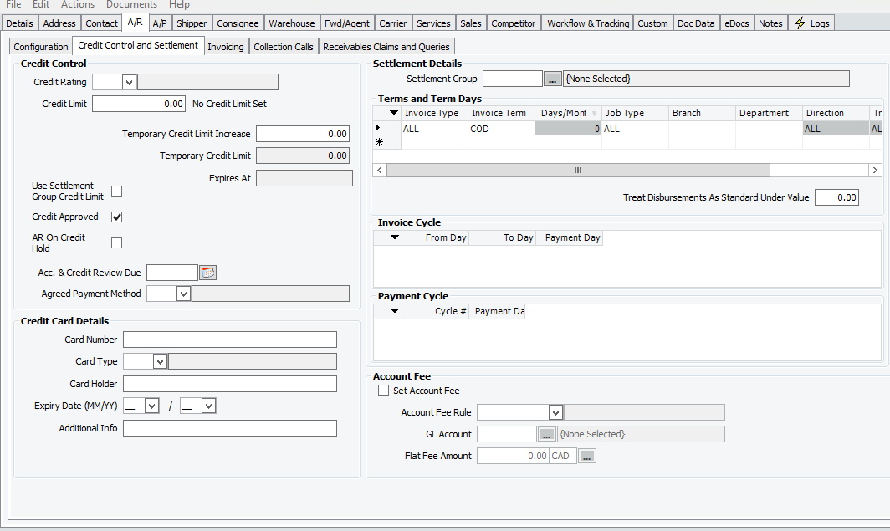

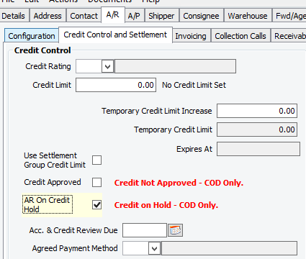

1. Change terms and term days

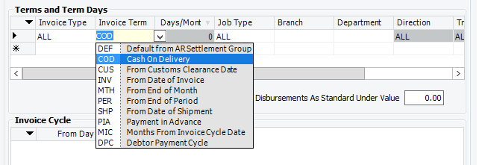

1. Click Notes: Internal Notes (Terms, any special instructions for OPS)

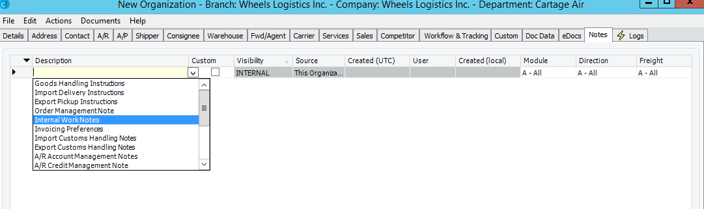

1. Enter credit limit

# 7.0 references

# 8.0 revision history

|  |  |  |
| --- | --- | --- |
| **Revision #** | **Revision Date** | **Description** |
|  |  |  |